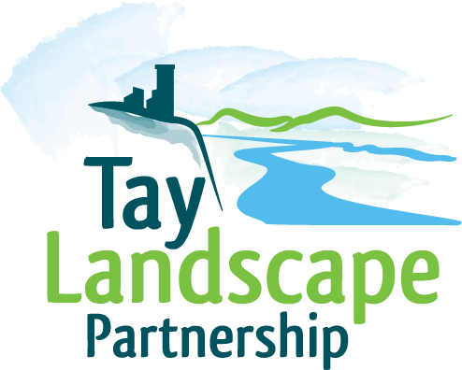

Tay Landscape Partnership Learning and Interpretation Project Officer
Perth and Kinross Heritage Trust

Perth
£25k p.a. pro rata

Fixed-term, 8 month period (June 2017 – end February 2018), 28.5 hours/week.

The Tay Landscape Partnership Scheme is in the final year of delivery of an exciting four year project celebrating the landscapes of where the Rivers Tay and Earn meet. Focussing on the estuarine landscape from Perth to Dundee, this £2.6 million initiative aims to reconnect residents and visitors with the natural, built and cultural heritage of the area through 29 individual projects which will:

- conserve, restore and improve access to a range of natural and historic features
- encourage and support a greater diversity and quantity of people to learn about and more actively participate in their landscape and its heritage
- provide training opportunities for people in local, traditional skills
- link with broader public and private to support sustainable economic development

We are looking for a committed individual to deliver the Learning and Interpretation role. You will have experience of:

- managing complex projects and budgets with a heritage/environmental theme.
- the Curriculum for Excellence programme.
- liaising and delivering a diverse range of learning activities with schools.
- managing budgets, problem solving and delivering within timescales.
- successful contract management.
- managing successful community engagement.
- recording, reporting on and promoting events and activities.
- working in a small team.

For further information or an informal discussion about the role please contact Shirley Paterson, TayLP Scheme Manager on 01738 477083. Application is by covering letter and c.v. - please download the job description and person specification from our website at www.taylp.org. Please state in your application where you saw this post advertised.

Closing date: 12 June 2017
Interview date: 26 June 2017
Start date: 1 July 2017

