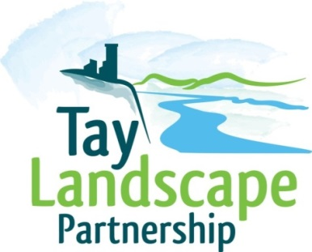
Art Award Application

SECTION 1 – Personal Details

Forename(s)

Surname

Title | Mr |  | Mrs |  | Miss |  | Ms |  | Dr
 | Other (please write)
Telephone No.

Mobile No.

Email
Date of Birth
House Name/Number

Address Line 1

Address Line 2
Address Line 3
Postcode
Blog or website

SECTION 2 – Education and Previous Experience
a) Current occupation(s) or student status
b) Please briefly tell us about your experience in your chosen artistic discipline, including the completion of any courses or exhibitions.
c) Please provide a brief explanation of a past project you completed (no more than 300 words). We would like to know about a personal or professional project. Please provide photographs of the work produced as a result of this project, these can be submitted by email or on disc to the address below. If they are available online please provide a link to the website.

SECTION 3 – The Proposal
Tell us why you feel you would be suitable for this award. Give details about your proposed project, including what you aim to achieve, what outcomes you hope to have and how you will spend the award.
Applicant signature: | Date:

Please submit your images on disc to:
Lisa Snedden
Tay Landscape Partnership
Learning and Interpretation Officer
Pullar House
35 Kinnoull Street
Perth
PH1 5GD

